TITLE OF THE ARTICLE (use ARtiCLE TITLE style or Alt + Ctrl + S)

The first author’s name, surname¹, The second author’s name, surname² (use Author names style or Alt + Ctrl + V)

¹Name and address of workplace or institution represented by the author (use Institution Address style or Alt + Ctrl + I)
²Name and address of workplace or institution represented by the author (use Institution Address style or Alt + Ctrl + I)

Abstract. Abstract must be written in original language (100 – 150 words). That is a brief one paragraph text which presents conducted scientific research with its aim, logical reasoning, applied research methods and the main conclusions or / and raised issues. (use Annotation style or Alt + Ctrl + A)

Key words: 4-7 words are provided, separated by commas. (use Keywords style or Alt + Ctrl + K)

Introduction (use Heading 1 style or Alt + Ctrl + N)
The introduction raises and substantiates the scientific issue, formulates the research subject, its aim and objectives, indicates the research methodology and expected results. (use Text style or Alt + Ctrl + T)

1. Title of section (use Heading 1 style or Alt + Ctrl + N)
A list of references should be provided in accordance with analysed issue of the article. APA citation standard (American Psychological Association, Lith. Amerikos psichologijos asociacija) is used in scientific magazine “Technologies and Art. Research and Topicalities”. References in the text are given indicating the name (-s) of the author (-s) and year of publication in brackets. The book of one author should be cited as follows: (Bhargava, 2019). The book of two authors should be cited as follows: (Razma and Čenkutė, 2018) or (Bozarth & Handfield, 2016). If a book of three or more authors is cited, only the first author is indicated, e.g.: (Lebedevas and others, 2019) or (Wang et al., 2017). If certain part of the text is cited, then the exact page of the source should be indicated, e.g.: (Mačerinskas and others, 2017, p. 85). If two different authors with the same surnames are cited, then their initials are indicated in the reference list, e.g.: (A. Bereczky, 2018; Z. Bereczky, 2019). Different sources of the same author published in the same year are cited as follows: (Zavadskas, 2018a; Zavadskas, 2019b). The letters a, b, c...., should be indicated after the year of publication in the reference list accordingly.
The example of cited institution, association or other type of author is given in the following example: (Vilnius College of Technologies and Design [VCTD], 2018) [first reference]; only (VCTD, 2019) [second and further times references]. If there is no author, then the title and the year of publication is indicated, e.g.: (Baltoji knyga dėl Europos ateities, 2017) or the first few words of the title are mentioned, e.g.: (Motorinių transporto priemonių..., 2016).

2. Title of section (use Heading 1 style or Alt + Ctrl + N)
Articles submitted to scientific magazine “Technologies and Art. Research and Topicalities” should correspond to the following requirements:
- Volume of the article: 4 – 8 pages. (use Bulleted list style or Alt + Ctrl + B)
- The article has to be written using text editor MS Word, Times New Roman style, 10 pt. (spaced by single (Single) interval).
- Abstract and key words are written in one column, justified alignment.
- Page formatting– A4 (21x29,7 cm), vertical, text is presented in two columns. Space between columns - 10 mm.
- Margins: left – 20 mm, right –10 mm, top – 30 mm, bottom – 20 mm.
- Paragraphs: first line indent – 0,7 cm, justified alignment.
- Font size and style is presented in the table below (1table).
1 Table. Font size, style and alignment (use Table style or Alt + Ctrl + L)
Text | Font size, alignment | Font style
Title | 12 pt., central | Bold,  CAPITAL  LETTERS
Author (-s) | 11 pt., central | Bold
Workplace,  Institution | 11 pt., central | Italics
Abstract | 9 pt., justified | Normal
Key words | 9 pt., justified | Normal
Titles of sections,  subsections | 11 pt., left | Bold
Main text | 10 pt., justified | Normal
Text in the table | 9 pt., left | Normal
Table title and  numbering | 9 pt, left | Normal
Image title,  numbering | 9 pt, central | Normal
Formulas | 10 pt. central | Italics
Reference list | 9 pt, justified | Normal
Summary | 9 pt, justified | Normal
Source: Author (-s)

- Tables are formatted together with the text, using justified alignment. Numbers of tables are written above the tables in Arabic style. Indication to the source is written under the table.
- Illustrations, pictures, diagrams or schemes used in the text are placed in the centre. The titles are written under illustrations in continuous order with indication to the source. Pictures and diagrams must be distinctive with expression no less than 300 DPI, greyscale (1 e.g.).

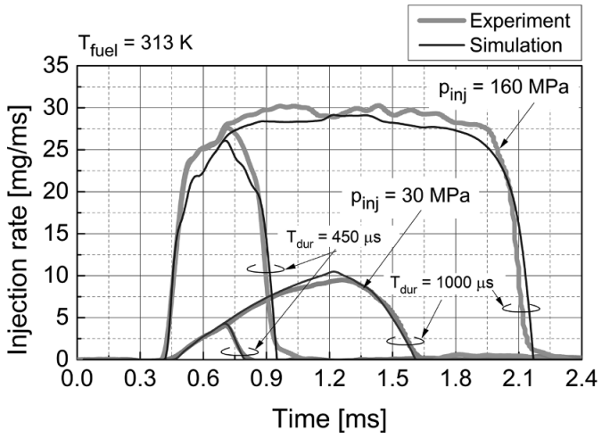
Fig 1. Graph Title (use Figure caption style or Alt + Ctrl + F)
Source: Author (-s)

- Mathematical formulas and other mathematical equations are inserted into the text in a new paragraph. Formulas are written using editor „Microsoft Equation 3.0“, formula numbering is on the right side, in Arabic style, in the brackets, for e.g.:

$$v_{st}=\frac{2·S·n}{60},$$ | (1)
(use Equation style or Alt + Ctrl + E)
here: S – piston force, m; n – speed of rotating engine shaft in, min⁻¹.

Conclusions (use Heading 1 style or Alt + Ctrl + N)
- Conclusions are provided using Arabic numbering style. (use Conclusions style or Alt + Ctrl + C)
- Conclusions and recommendations should support the aim and objectives of scientific article.

Reference list: (use Heading 1 style or Alt + Ctrl + N)
Detailed list of references is provided at the end of the article. Authors are indicated in alphabetical order. If there are no authors indicated, the publications should be written in alphabetical order according to their titles. Sources which are written not in Latin characters should be provided at the end of the reference list. If few articles of the same author were published in the same year, they should be given the letters a, b, c..., after publication year. Examples of reference list: (use References style or Alt + Ctrl + R)
Keskin, A., Guru, M. and Altiparmak, D. (2007). Biodiesel production from tall oil with synthesized Mn and Ni based additives: effects of the additives on fuel consumption and emissions, Fuel 86 (7), 1139-1143. doi.org/10.1016/j.fuel.2006.10.021. (Article in serial publications).
Valiulis, A.V. (2013). Engineering Materials Science: Structure, Properties and Applications. ISBN 9786094574658. doi: 10.3846/1473-S Access via internet: https://www.ebooks.vgtu.lt/product/engineering-materials- science-structure-properties-applications >. (E-book).
Vares, V., Kask, U., Muiste, P., Pihu, T. and Soosaar, S. (2007).
Biokuro naudotojo žinynas. Access via internet:
<http://enmin.lrv.lt/lt/veiklos-sritys-3/atsinaujinantys- energijos-istekliai/tyrimai-ir-analizes-3>. (Internet page).
Vekteris, V., Kasparaitis, A., Kaušinis, S and Kanapėnas, R. (2000). Matavimų teorija ir praktika. Vilnius: Žiburio leidykla. 381 p. ISBN 9986524261. (Book)
More information on guidelines for citation and reference list: https://www.mendeley.com/guides/apa-citation-guide
(use References style or Alt + Ctrl + R)

TITLE OF THE ARTICLE IN FOREIGN LANGUAGE (use ARtiCLE TITLE in FOREIGN style or Alt + Ctrl + D)

The first author’s name, surname¹, (use Author names in Foreign style or Alt + Ctrl + G)
The second author’s name, surname² , (use Author names in Foreign style or Alt + Ctrl + G)

¹Name and address of workplace or institution represented by the author (use Institution Address Foreign style or Alt + Ctrl + P)
²Name and address of workplace or institution represented by the author (use Institution Address Foreign style or Alt + Ctrl + P)

Summary. Summary (200 – 250 words) is written in a language other than the article language. If the article is written in English, the summary is provided in Lithuanian. If the article is written in Lithuanian, the summary is provided in English. (use Annotation style or Alt + Ctrl + A)
Key words: First keyword, second keyword, third keyword. (use Keywords style or Alt + Ctrl + K).

